R Tutorial: Create Elegant Data Visualization Using the Grammar of Graphics
“The simple graph has brought more information to the data analyst’s mind than any other device.” - John Tukey
“The greatest value of a picture is when it forces us to notice what we never expected to see.”
- John Tukey
- Introduction
R has several systems for making graphs, but ggplot2 is one of the most elegant and most versatile. ggplot2 implements the grammar of graphics, a coherent system for describing and building graphs. With ggplot2, you can do much faster by learning one system and applying it in many places.
If you’d like to learn more about the theoretical underpinnings of ggplot2 before you start, please read “The Layered Grammar of Graphics”.

Prerequisites: this section focusses on ggplot2, one of the core members of the tidyverse. To access the datasets, help pages, and functions that we will use in this chapter, load the tidyverse by running this code:
> library(tidyverse)
Loading tidyverse: ggplot2
Loading tidyverse: tibble
Loading tidyverse: tidyr
Loading tidyverse: readr
Loading tidyverse: purrr
Loading tidyverse: dplyr
Conflicts with tidy packages ------------------------------------------------------
filter(): dplyr, stats
lag(): dplyr, stats

This one line of code loads the core tidyverse, package which you will use in almost every data analysis. It also tells you which functions from the tidyverse conflict with functions in base R (or from other packages you might have loaded).
If you run this code and get the error message “there is no package called ‘tidyverse’”, you will need to first install it, then run library() once again.
> install.packages("tidyverse")
> library(tidyverse)

You only need to install a package once, but you need to reload it every time you start a new session.

- Creating a ggplot
2.1 The mpg data frame
We will use our first graph to answer a question: Do cars with big engines use more fuel than cars with small engines? You probably already have an answer, but try to make your answer precise. What does the relationship between engine size and fuel efficiency look like? Is it positive? Negative? Linear? Nonlinear?

You can test your answer with the mpg data frame in ggplot2 (aka ggplot2::mpg). A data frame is a rectangular collection of variables (in the columns) and observations (in the rows). Mpg contains observations collected by the US Environment Protection Agency on 38 models of cars.
> mpg
# A tibble: 234 x 11

Among the variables in mpg are:
- displ, a car’s engine size, in litres.
- hwy, a car’s fuel efficiency on the highway, in miles per gallon (mpg). A car with a low fuel efficiency consumes more fuel than a car with a high fuel efficiency when they travel the same distance.
- To learn more about mpg, open its help page by running ?mpg.

  - Creating a ggplot.
To plot mpg, run this code to put displ on the x-axis and hwy on the y-axis:
> ggplot(data=mpg) +
geom_point(mapping = aes(x=displ, y=hwy))

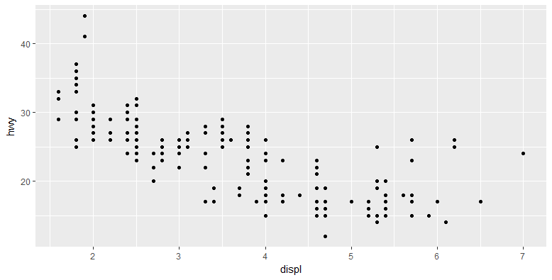
The plot shows a negative relationship between engine size (displ) and fuel efficiency (hwy). In other words, cars with big engines use more fuel. Does this confirm or refute your hypothesis about fuel efficiency and engine size?
With ggplot2, you begin a plot with the function ggplot(). ggplot() creates a coordinate system that you can add layers to. The first argument of ggplot() is the dataset to use in the graph. So ggplot(data=mpg) creates an empty graph.
The graph is completed by adding one or more layers to ggplot(). The function geom_point() adds a layer of points to the plot, which creates a scatter plot. Previously, we use plot(x, y), now we can try ggplot() + geom_point(). And ggplot comes with many geom functions that each add a different type of layer to a plot. We will introduce a whole bunch of them.
Each geom function in ggplot2 takes a mapping argument. This defines how variables in your dataset are mapped to visual properties. The mapping argument is always paired with aes(), and the x and y arguments of aes() specify which variables to map to the x and y axes. ggplot2 looks for the mapped variable in the data argument, in this case, mpg.
Let’s turn this code into a reusable template for making graphs with ggplot2. To make a graph, replace the bracketed section in the code below with a dataset, a geom function, or a collection of mappings.
ggplot(data = <DATA>) +
<GEOM_FUNCTION> (mapping = aes( <MAPPINGS> ))
The rest of the this section will show how to complete and extend this template to make different types of graphs.

3. Aesthetic mappings
In the plot above, one group of points (highlighted in red) seems to fall outside of the linear trend. These cars have a higher mileage than you might expect. How can you explain these cars?
You can add a third variable, like class, to a two dimensional scatterplot by mapping it to an aesthetic. An aesthetic is a visual property of the objects in your plot. Aesthetics include things like the size, the shape, or the color of your points. You can display a point in different ways by changing the values of its aesthetic properties. Since we already use the word “value” to describe data, let’s use the word “level” to describe aesthetic properties.
You can convey information about your data by mapping the aesthetics in your plot to the variables in your dataset. For example, you can map the colors of your points to the class variable to reveal the class of each car.
> ggplot(data=mpg) +
geom_point(mapping = aes(x=displ, y=hwy, color=class))
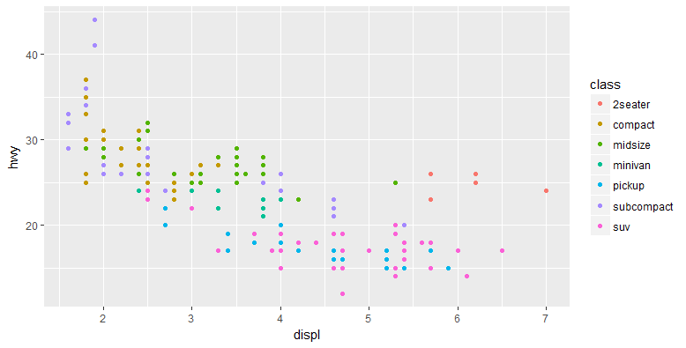
(If you prefer British English, you can use colour instead of color.)
In the above example, we mapped class to the color aesthetic, but we could have mapped class to the size aesthetic in the same way. In this case, the exact size of each point would reveal its class affiliation. We get a warning here, because mapping an unordered variable (class) to an ordered aesthetic (size) is not a good idea.
> ggplot(data=mpg) +
geom_point(mapping = aes(x=displ, y=hwy, size=class))
Warning message:
Using size for a discrete variable is not advised

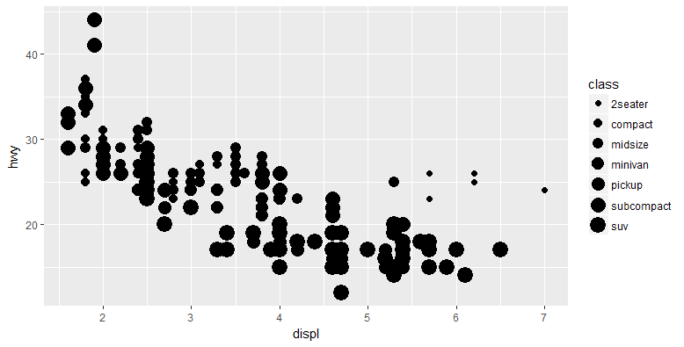
Or we could have mapped class to the alpha aesthetic, which controls the transparency of the points, or the shape of the points.
> ggplot(data=mpg) +
geom_point(mapping = aes(x=displ, y=hwy, alpha=class))
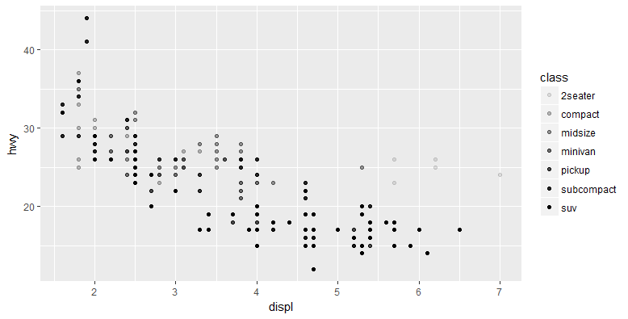
> ggplot(data=mpg) +
geom_point(mapping = aes(x=displ, y=hwy, shape=class))
Warning messages:
1: The shape palette can deal with a maximum of 6 discrete values because more
than 6 becomes difficult to discriminate; you have 7. Consider specifying
shapes manually if you must have them.
2: Removed 62 rows containing missing values (geom_point).
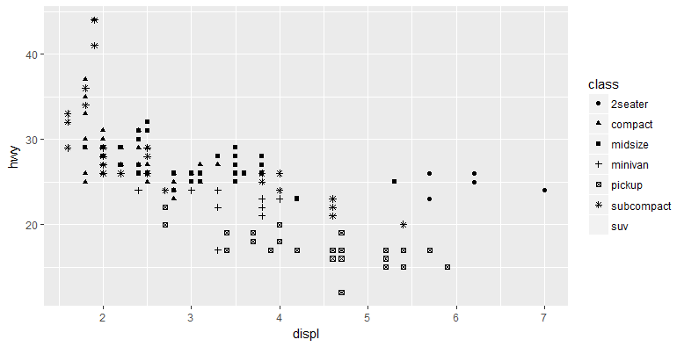
What happened to the SUVs is that ggplot2 only use six shapes at a time. By default, additional groups will go unplotted when you use the shape aesthetic.
Once you map an aesthetic, ggplot takes care of the rest. It selects a reasonable scale to use with the aesthetic, and it constructs a legend that explains the mapping between levels and values. For x and y aesthetics, ggplot2 does not create a legend, but it creates an axis line with tick marks and a lable. The axis line acts as a legend; it explains the mapping between locations and values.
You can also set the aesthetic properties of your geom manually. For example, we can make all of the points in our plot blue.
> ggplot(data=mpg) +
geom_point(mapping = aes(x=displ, y=hwy), color="blue")
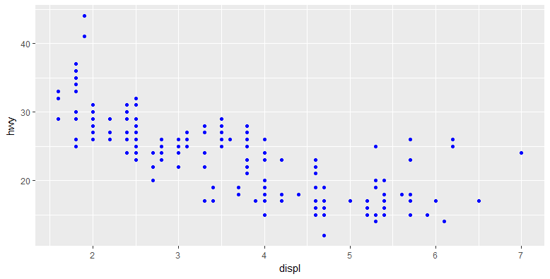
Here color does not convey information about a variable, but only changes the appearance of the plot. To set an aesthetic manually, set the aesthetic by name as an argument of your geom function. It goes outside of aes(). You will need to pick a value that makes sense for that aesthetic.
- The name of a color as a character string
- The size of a point in mm
- The shape of a point as a number, as shown below.
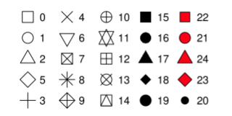
4. Facets
One way to add additional variables is with aesthetics. Another way, particularly useful for categorical variables, is to split your plot into facets, subplots that display one subset of the data.
To facet your plot by a single variable, use facet_wrap(). The first argument of facet_wrap() should be a formula, which you create with ~ followed by a variable name (here “formula” is the name of a data structure in R, not a synonym for “equation”). The variable that you pass to facet_wrap() should be discrete.

> ggplot(data=mpg) +
geom_point(mapping=aes(x=displ, y=hwy)) +
facet_wrap(~class, nrow=2)
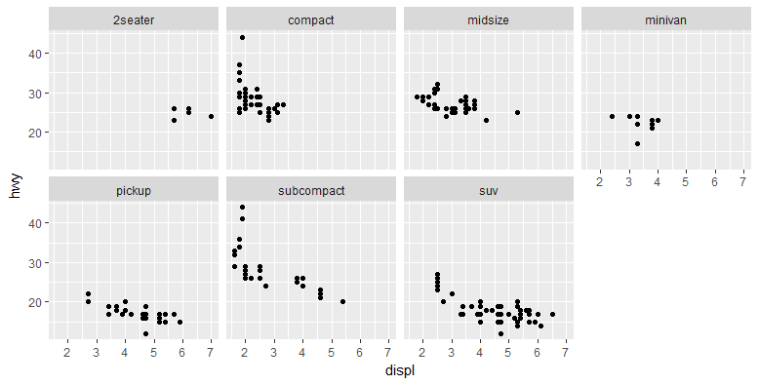
To facet your plot on the combination of two variables, add facet_grid() to your plot call. The first argument of facet_grid() is also a formula. This time the formula should contain two variable names separated by a ~.
> ggplot(data=mpg) +
geom_point(mapping=aes(x=displ, y=hwy)) +
facet_grid(drv~cyl)
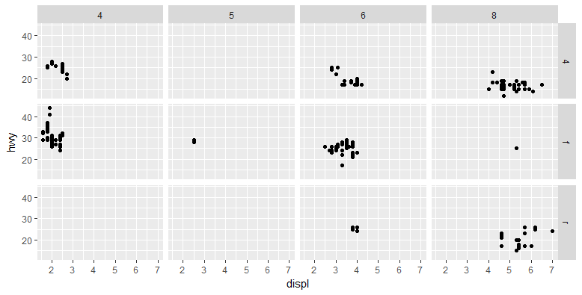
5. Geometric Objects
A geom is the geometrical object that a plot uses to represent data. People often describe plots by the type of geom that the plot uses. For example, bar charts use bar geom, line charts use line geoms, boxplots use boxplot geoms, and so on. Scatterplots break the trend; they use the point geom. You can use the different geoms to plot the same data.
To change the geom in your plot, change the geom function that you add to ggplot(). For instance, to make the plots below, you can use the code:

> ggplot(data=mpg) +
geom_point(mapping=aes(x=displ, y=hwy))

> ggplot(data=mpg) +
geom_smooth(mapping=aes(x=displ, y=hwy))
`geom_smooth()` using method = 'loess'
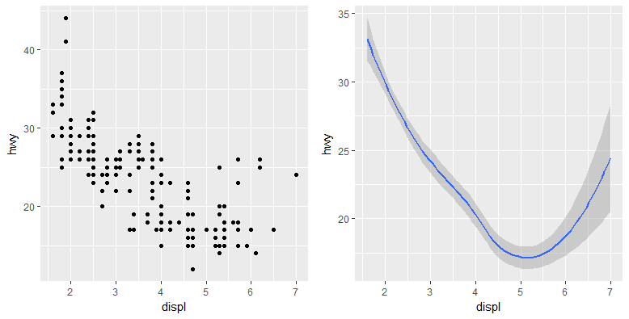
Every geom fuction in ggplot2 takes a mapping argument. However, not every aesthetic works with every geom. You could set the shape of a point, but you cannot set the “shape” of a line. One the other hand, you could set the “linetype” of a line. geom_smooth() will draw a different line, with a different linetype, for each value of the variable you map.

> ggplot(data=mpg) +
+ geom_smooth(mapping=aes(x=displ, y=hwy, linetype=drv))
`geom_smooth()` using method = 'loess'
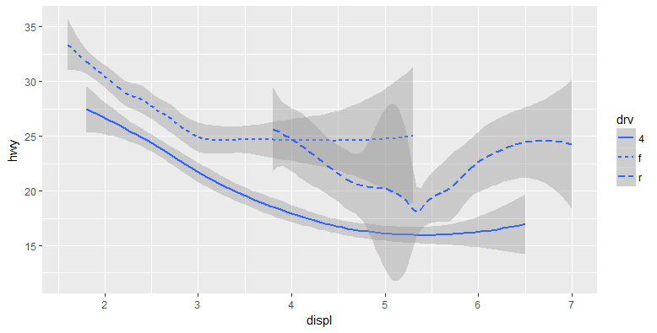
Here geom_smooth() separates the cars into three lines based on their drv value, which describes a car’s driventrain. One line describes all of the points with a 4 value; one line describes all of the points with a f value; and one line describes all of the points with a r value. Here, 4 stands for four-wheel drive, f for front-wheel drive, and r for rear-wheel drive.
We can make this more clear by overlaying the lines on top of the raw data and then coloring everything according to drv.

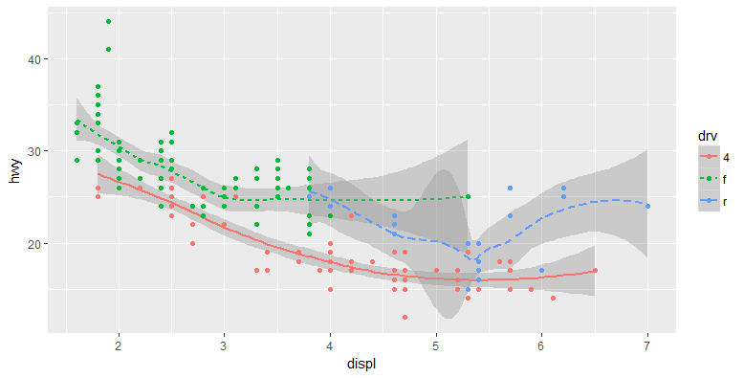
Notice that this plot contains two geoms in the same graph. Ggplot2 provides over 30 geoms, and extension packages provide even more. A best way to get a comprehensive overview is the ggplot2 cheatsheet.
In practice, ggplot2 will automatically group the data for these geoms whenever you map an aesthetic to a discrete variable (as in the linetype example). It is convenient to rely on this feature because the group aesthetic by itself does not add a legend or distinguishing features to the geoms.

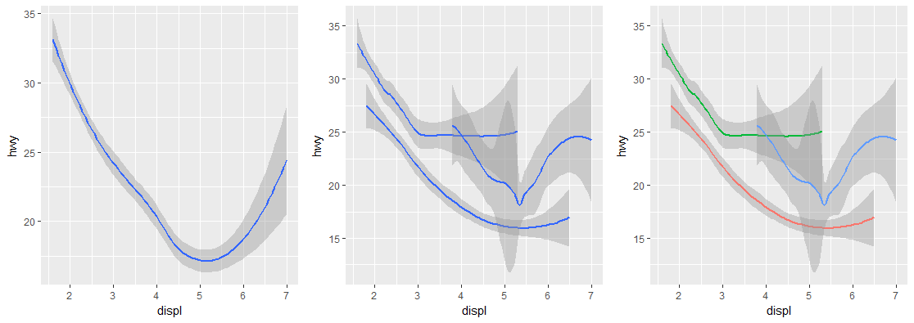
> ggplot(data = mpg) +
geom_smooth(mapping = aes(x = displ, y = hwy))

> ggplot(data = mpg) +
geom_smooth(mapping = aes(x = displ, y = hwy, group = drv))

> ggplot(data = mpg) +
geom_smooth(
mapping = aes(x = displ, y = hwy, color = drv),
show.legend = FALSE
)

To display multiple geoms in the same plot, add multiple geom functions to ggplot():
> ggplot(data=mpg) +
geom_smooth(mapping=aes(x=displ, y=hwy)) +
geom_point(mapping=aes(x=displ, y=hwy))

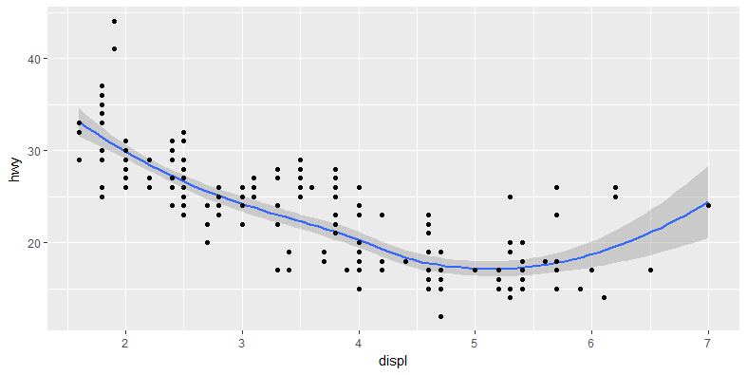

This, however, introduces some duplication in our code. Imagine if you wanted to change the y-axis to display cty instead of hwy. You’d need to change the variable in two places, and you might forget to update one. You can avoid this type of repetition by passing a set of mappings to ggplot(). ggplot2 will treat these mappings as global mappings that apply to each geom in the graph. In other words, this code will produce the same plot as the previous code:

> ggplot(data = mpg, mapping = aes(x = displ, y = hwy)) +
geom_point() +
geom_smooth()

If you place mappings in a geom function, ggplot2 will treat them as local mappings for the layer. It will use these mappings to extend or overwrite the global mappings for that layer only. This makes it possible to display different aesthetics in different layers.
> ggplot(data = mpg, mapping = aes(x = displ, y = hwy)) +
geom_point(mapping = aes(color = class)) +
geom_smooth()

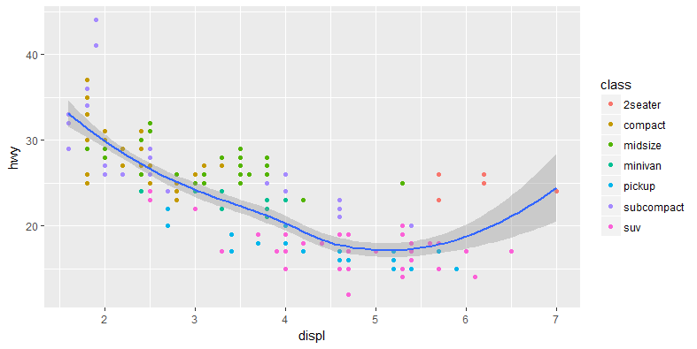
You can use the same idea to specify different data for each layer.
- Label
The easiest place to start when turning an exploratory graphic into an expository graphic is with good labels. You add labels with the labs() function. This example adds a plot title:
> ggplot(mpg, aes(displ, hwy)) +
geom_point(aes(color=class)) +
geom_smooth(se=FALSE) +
labs(
title="Fuel efficiency generally decrease with engine size"
)
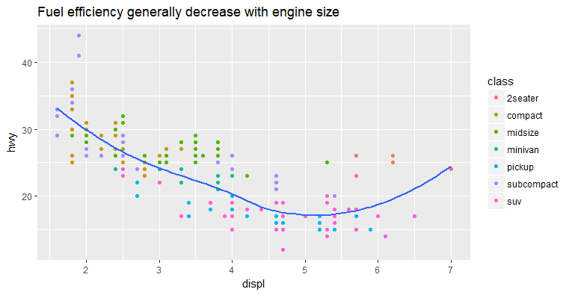
The purpose of a plot title is to summarize the main finding. Avoid titles that just describe what the plot is, e.g., “A scatterplot of engine displacement vs. fuel economy.”
If you need to add more text, there are two other useful labels that you can use in ggplot2:
- subtitle adds additional detail in a smaller font beneath the title.
- caption adds text at the bottom right of the plot, often used to describe the source of the data:
> ggplot(mpg, aes(displ, hwy)) +
geom_point(aes(color=class)) +
geom_smooth(se=FALSE) +
labs(
title="Fuel efficiency generally decrease with engine size",
subtitle="Two seaters (sports cars) are an exception because of their light weight",
caption="Data from fueleconomy.gov"
)
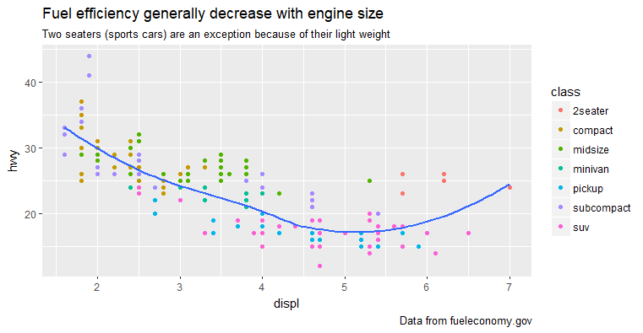
You can also use labs() to replace the axis and legend titles. It’s usually a good idea to replace short variable names with more detailed descriptions, and to include the units:
> ggplot(mpg, aes(displ, hwy)) +
geom_point(aes(color=class)) +
geom_smooth(se=FALSE) +
labs(
x = "Engine displacement (L)",
y = "Highway fuel economy (mpg)",
color = "Car type"
)
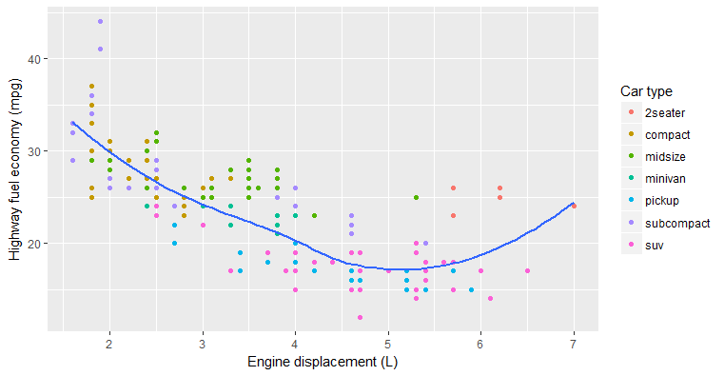
It’s possible to use mathematical equations instead of text strings. Just switch "" out for quote() and read about the available options in ?plotmath:
> df <- tibble(
x = runif(10),
y = runif(10)
)
> ggplot(df, aes(x, y)) +
geom_point() +
labs(x = quote(sum(x[i]^2, i==1, n)),
y = quote(alpha + beta + frac(delta, theta))
)
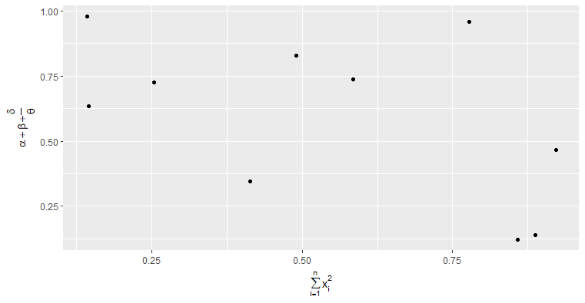
- Annotations
In addition to labeling major components of your plot, it’s often useful to label individual observations or groups of observations. The first tool you have at your disposal is geom_text(). geom_text() is similar to geom_point(), but it has an additional aesthetic: label. This makes it possible to add textual labels to your plots.
There are two possible sources of labels. First, you might have a tibble that provides labels. The following plot isn’t terribly useful, but it illustrates a useful approach—pull out the most efficient car in each class with dplyr, and then label it on the plot:
> best_in_class <- mpg %>%
group_by(class) %>%
filter(row_number(desc(hwy)) == 1)

> ggplot(mpg, aes(displ, hwy)) +
geom_point(aes(color = class)) +
geom_text(aes(label = model), data=best_in_class)
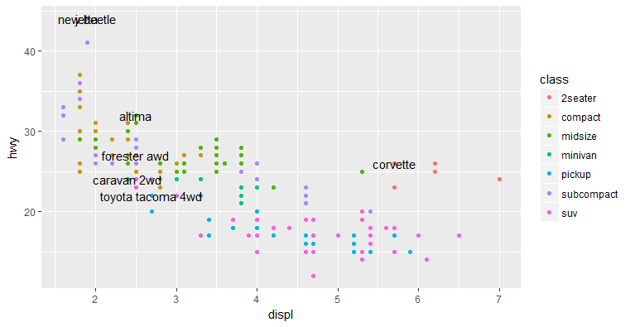
This is hard to read because the labels overlap with each other, and with the points. We can make things a little better by switching to geom_label(), which draws a rectangle behind the text. We also use the nudge_y parameter to move the labels slightly above the corresponding points:
> ggplot(data=mpg, aes(displ, hwy)) +
geom_point(aes(color = class)) +
geom_label(aes(label = model), data=best_in_class, nudge_y=2, alpha=0.5)

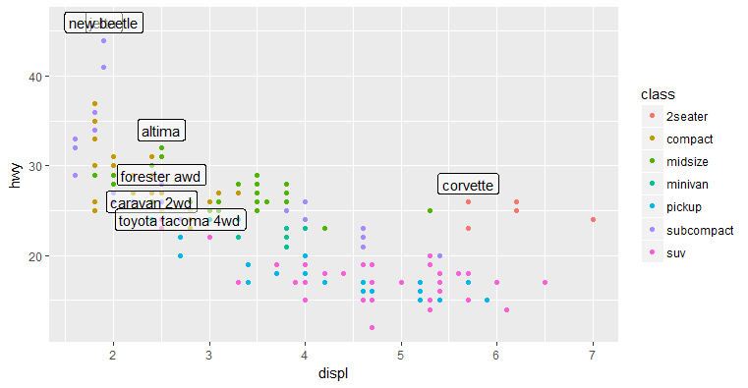
That helps a bit, but if you look closely in the top left hand corner, you’ll notice that there are two labels practically on top of each other. This happens because the highway mileage and displacement for the best cars in the compact and subcompact categories are exactly the same. There’s no way that we can fix these by applying the same transformation for every label. Instead, we can use the ggrepel package by KamilSlowikowski. This useful package will automatically adjust labels so that they don’t overlap:
> ggplot(data=mpg, aes(displ, hwy)) +
geom_point(aes(color = class)) +
geom_point(size=3, shape=1, data = best_in_class) +
ggrepel::geom_label_repel(
aes(label = model),
data = best_in_class)
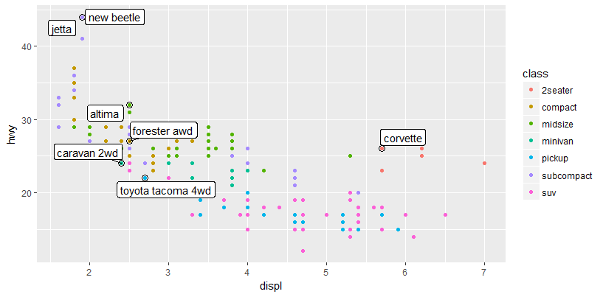
Alternatively, you might just want to add a single label to the plot, but you’ll still need to create a data frame. Often, you want the label in the corner of the plot, so it’s convenient to create a new data frame using summarize() to compute the maximum values of x and y:
> label <- mpg %>%
summarize(
displ = max(displ),
hwy = max(hwy),
label = "Increasing engine size is \n related to decreasing fuel economy" )

> ggplot(mpg, aes(displ, hwy)) +
geom_point() +
geom_text(
aes(label = label),
data = label,
vjust = "top",
hjust = "right"
)
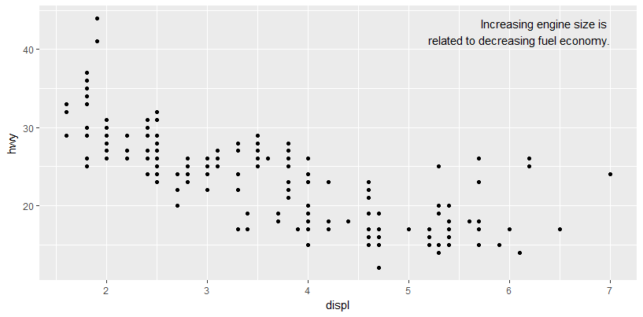
In this examples, I manually broke the label up into lines using"\n". Note the use of hjust and vjust to control the alignment of the label.
If you want to place the text exactly on the borders of the plot, you can use +Inf and -Inf. Since we’re no longer computing the positions from mpg, we can use tibble() to create the data frame:
> label <- tibble(
displ = Inf,
hwy = Inf,
label = "Increasing engine size is \n related to decreasing fuel economy."
)
> ggplot(mpg, aes(displ, hwy)) +
geom_point() +
geom_text(
aes(label = label),
data = label,
vjust = "top",
hjust = "right"
)
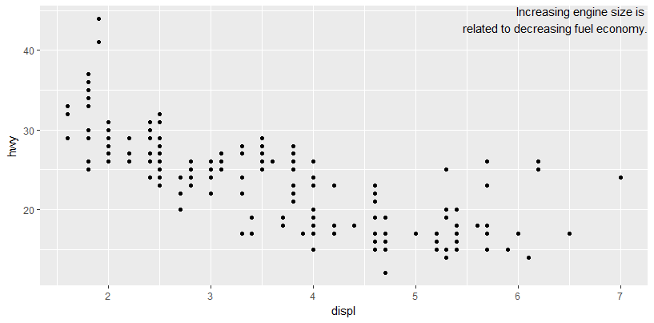
Remember, in addition to geom_text(), you have many other geoms inggplot2 available to help annotate your plot. A few ideas:
- Use geom_hline() and geom_vline() to add reference lines. You can make them thick (size = 2) and white (color = white), and draw them underneath the primary data layer. That makes them easy to see, without drawing attention away from the data.
- Use geom_rect() to draw a rectangle around points of interest. The boundaries of the rectangle are defined by the xmin, xmax, ymin, and ymax aesthetics.
- Use geom_segment() with the arrow argument to draw attention to a point with an arrow. Use the x and y aesthetics to define the starting location, and xend and yend to define the end location.

- Scales
The third way you can make your plot better for communication is to adjust the scales. Scales control the mapping from data values to things that you can perceive. Normally, ggplot2 automatically adds scales for you. For example, when you type:
> ggplot(mpg, aes(displ, hwy)) +
geom_point(aes(color = class))

ggplot2 automatically adds default scales behind the scenes:
> ggplot(mpg, aes(displ, hwy)) +
geom_point(aes(color = class)) +
scale_x_continuous() +
scale_y_continuous() +
scale_color_discrete()

Note the naming scheme for scales: scale_ followed by the name of the aesthetic, then _, then the name of the scale. The default scales are named according to the type of variable they align with: continuous, discrete, datetime, or date. There are lots of nondefault scales, which you’ll learn about next.
The default scales have been carefully chosen to do a good job for a wide range of inputs. Nevertheless, you might want to override the defaults for two reasons:
- You might want to tweak some of the parameters of the default scale. This allows you to do things like change the breaks on the axes, or the key labels on the legend.
- You might want to replace the scale altogether, and use a completely different algorithm. Often you can do better than the default because you know more about the data.

- Axis Ticks and Legend Keys
There are two primary arguments that affect the appearance of the ticks on the axes and the keys on the legend: breaks and labels. Breaks controls the position of the ticks, or the values associated with the keys. labels controls the text label associated with each tick/key. The most common use of breaks is to override the default choice:
> ggplot(mpg, aes(displ, hwy)) +
geom_point(aes(color = class)) +
scale_y_continuous(breaks = seq(15, 40, by = 5))
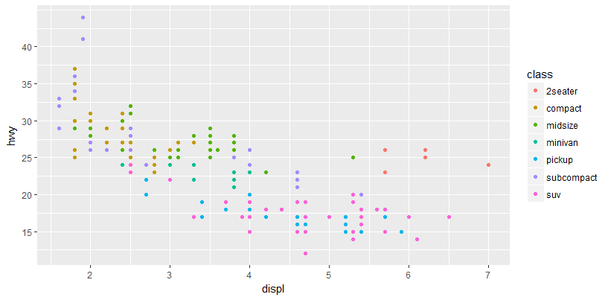
You can use labels in the same way (a character vector the same length as breaks), but you can also set it to NULL to suppress the labels altogether. This is useful for maps, or for publishing plots where you can’t share the absolute numbers:
> ggplot(mpg, aes(displ, hwy)) +
geom_point(aes(color = class)) +
scale_y_continuous(labels = NULL) +
scale_x_continuous(labels = NULL)

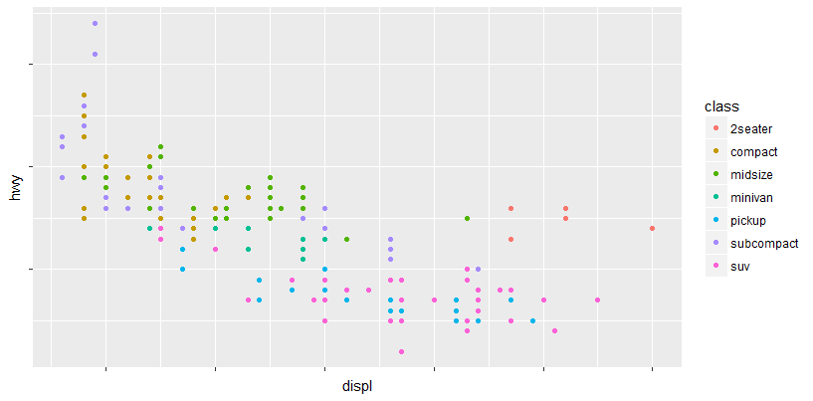
- Legend Layout
You will most often use breaks and labels to tweak the axes. While they both also work for legends, there are a few other techniques you are more likely to use.
To control the overall position of the legend, you need to use a theme() setting. In brief, they control the nondata parts of the plot. The theme setting legend.position controls where the legend is drawn:
> base <- ggplot(mpg, aes(displ, hwy)) +
geom_point(aes(color = class))

> base + theme(legend.position = "left")
> base + theme(legend.position = "right")
> base + theme(legend.position = "top")
> base + theme(legend.position = "bottom")

You can also use legend.position = "none" to suppress the display of the legend altogether.
To control the display of individual legends, use guides() along with guide_legend() or guide_colorbar(). The following example shows two important settings: controlling the number of rows the legend uses with nrow, and overriding one of the aesthetics to make the points bigger. This is particularly useful if you have used a low alpha to display many points on a plot:
> ggplot(mpg, aes(displ, hwy)) +
geom_point(aes(color = class)) +
geom_smooth(se = FALSE) +
theme(legend.position = "bottom") +
guides(
color = guide_legend(
nrow = 1,
override.aes = list(size = 4)
)
)
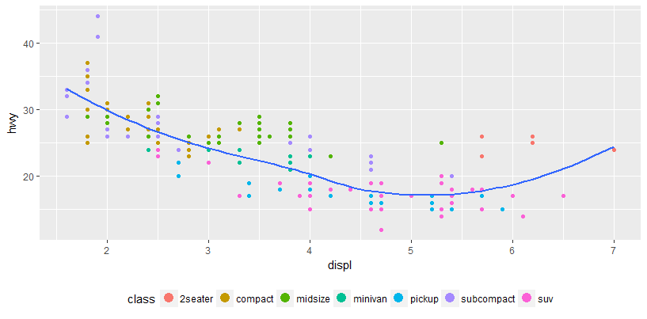
- Replacing a Scale
Instead of just tweaking the details a little, you can replace the scale altogether. There are two types of scales you’re most likely to want to switch out: continuous position scales and color scales. Fortunately, the same principles apply to all the other aesthetics, so once you’ve mastered position and color, you’ll be able to quickly pickup other scale replacements.
It’s very useful to plot transformations of your variable. For example, in the diamonds data set, it’s easier to see the precise relationship between carat and price if we log-transform them:
> ggplot(diamonds, aes(carat, price)) +
geom_bin2d()
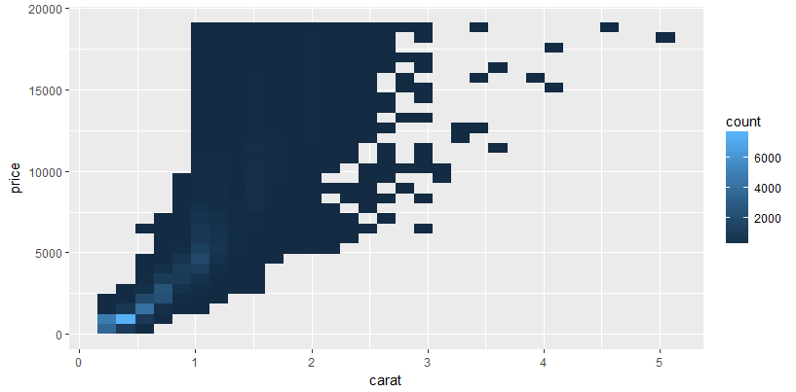
> ggplot(diamonds, aes(log10(carat), log10(price))) +
geom_bin2d()

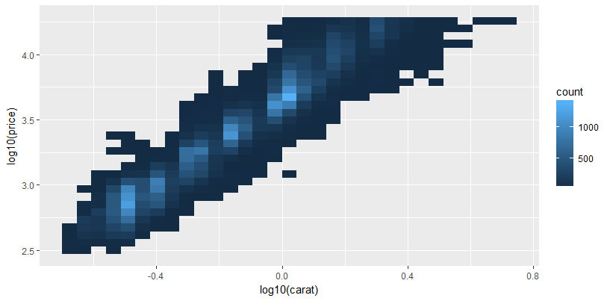
However, the disadvantage of this transformation is that the axes are now labeled with the transformed values, making it hard to interpret the plot.
Instead of doing the transformation in the aesthetic mapping, we can instead do it with the scale. This is visually identical, except the axes are labeled on the original data scale:
> ggplot(diamonds, aes(carat, price)) +
geom_bin2d() +
scale_x_log10() +
scale_y_log10()
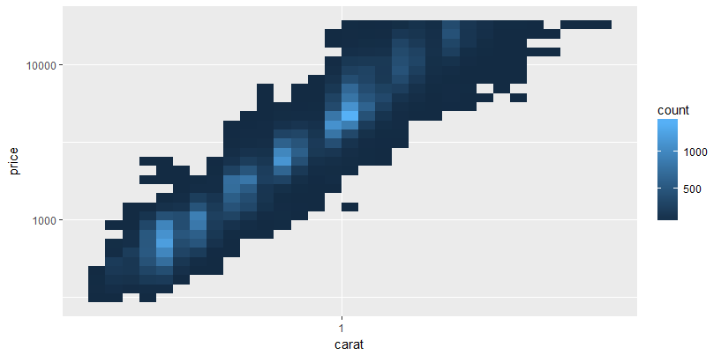
Another scale that is frequently customized is color. The default categorical scale picks colors that are evenly spaced around the color wheel. Useful alternatives are the Color Brewer scales, which have been hand-tuned to work better for people with common types of colorblindness. The following two plots look similar, but there is enough difference in the shades of red and green that the dots on the bottom can be distinguished even by people with red-green color blindness:
> ggplot(mpg, aes(displ, hwy)) +
geom_point(aes(color = drv))

> ggplot(mpg, aes(displ, hwy)) +
geom_point(aes(color = drv)) +
scale_color_brewer(palette = "Set1")
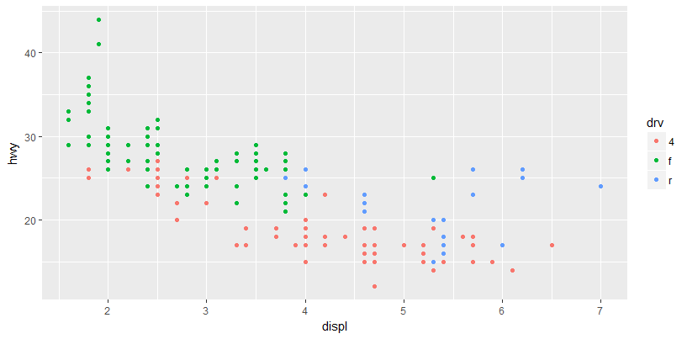
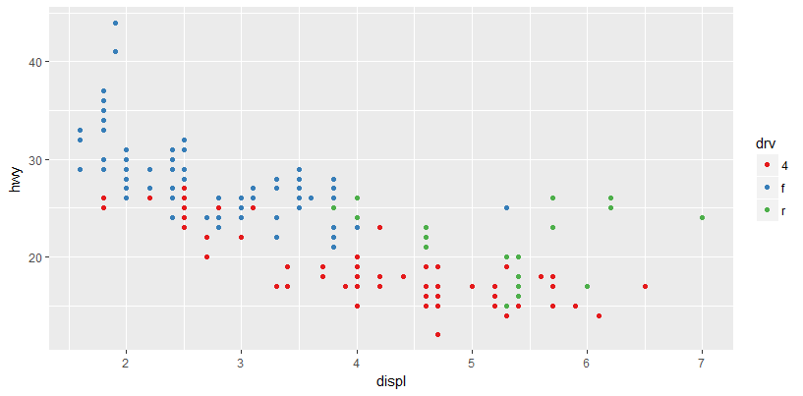
Don’t forget simpler techniques. If there are just a few colors, you can add a redundant shape mapping. This will also help ensure your plot is interpretable in black and white:
> ggplot(mpg, aes(displ, hwy)) +
geom_point(aes(color = drv, shape = drv)) +
scale_color_brewer(palette = "Set1")
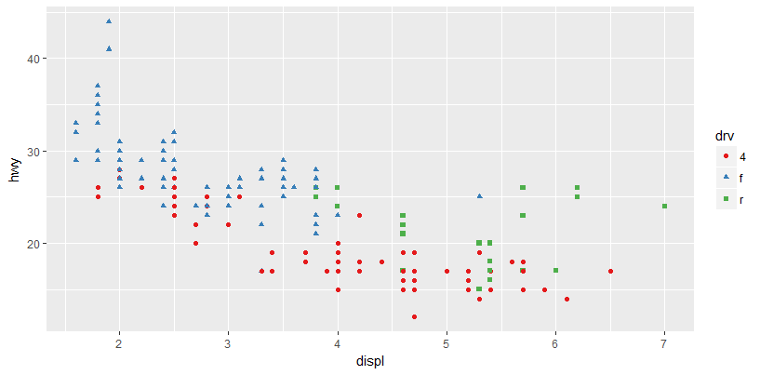
The ColorBrewer scales are documented online at http://colorbrewer2.org/ and made available in R via the RColorBrewer package, by Erich Neuwirth.
The sequential and diverging palettes are particularly useful if your categorical values are ordered. This often arises if you’ve used cut() to make a continuous variable into a categorical variable.
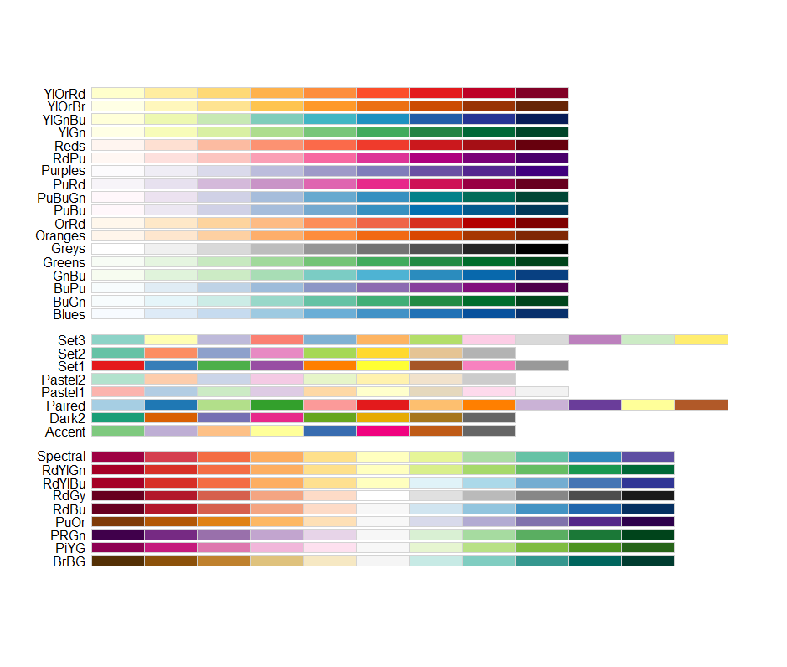

- Themes
Finally, you can customize the nondata elements of your plot with a theme:
> ggplot(mpg, aes(displ, hwy)) +
geom_point(aes(color = class)) +
geom_smooth(se = FALSE) +
theme_bw()

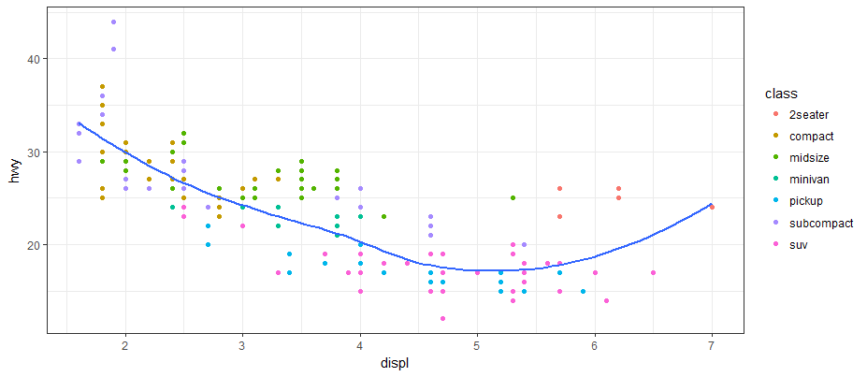
ggplot2 includes eight themes by default. Many more are included in add-on packages like ggthemes, by Jeffrey Arnold.
The gray background was a deliberate choice because it puts the data forward while still making the grid lines visible. The white grid lines are visible (which is important because they significantly aid position judgments), but they have little visual impact and we can easily tune them out. The gray background gives the plot a similar typographic color to the text, ensuring that the graphics fit in with the flow of a document without jumping out with a bright white background. Finally, the gray background creates a continuous field of color, which ensures that the plot is perceived as a single visual entity. It’s also possible to control individual components of each theme, like the size and color of the font used for the y-axis. You’ll need to read the ggplot2 book for the full details. You can also create your own themes, if you are trying to match a particular corporate or journal style.
